

**Appeals Status**

*Allows Veterans to view their current appeals status, alerts for deadlines where action is needed, next events of their status, time estimates until the next event, and issues on their appeal.*

**Who can access it?**

Veterans with a compensation appeal. Right now, as Vets.gov is in its growing phase, this tool isn’t available for dependents, 3rd party advocates, Veterans Service Organizations, or anyone else aside from Veterans or appellants who are continuing the appeal.

**How can users access it?**

Users can log in using their DS Log on, which is the same account for eBenefits, or by creating an IDme account.



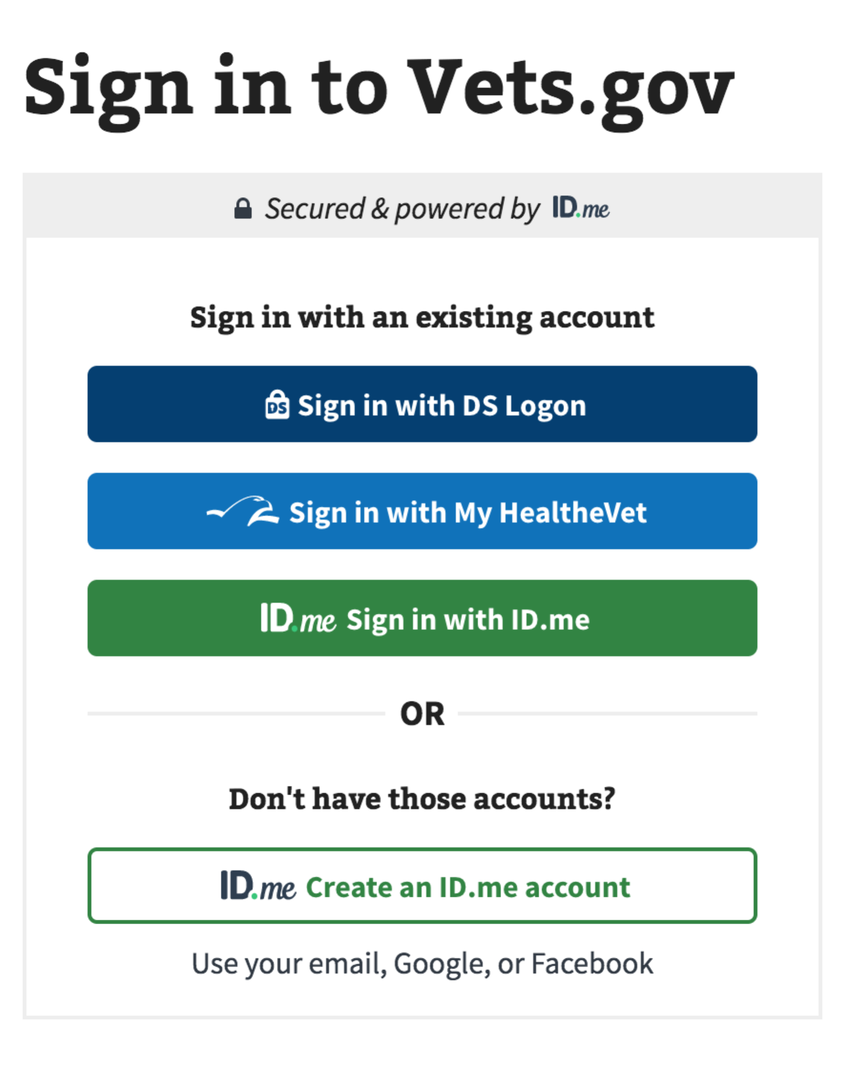

**Option 1:** Vets.gov >>  *[user name]* >> Account >> Check your claims and appeals status

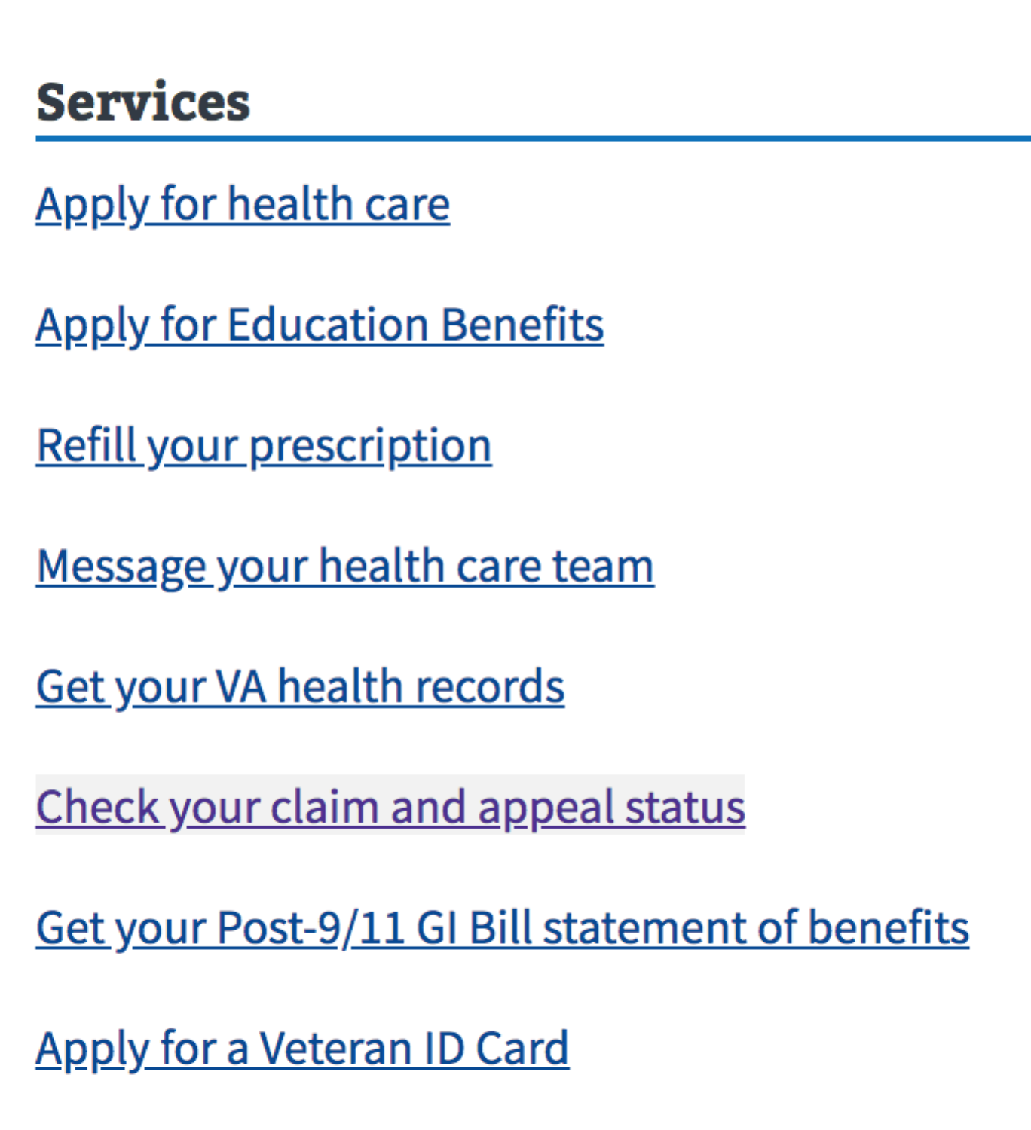

**Option 2:** Vets.gov >> Manage Your Health and Benefits >> Track Your Claims and Appeals

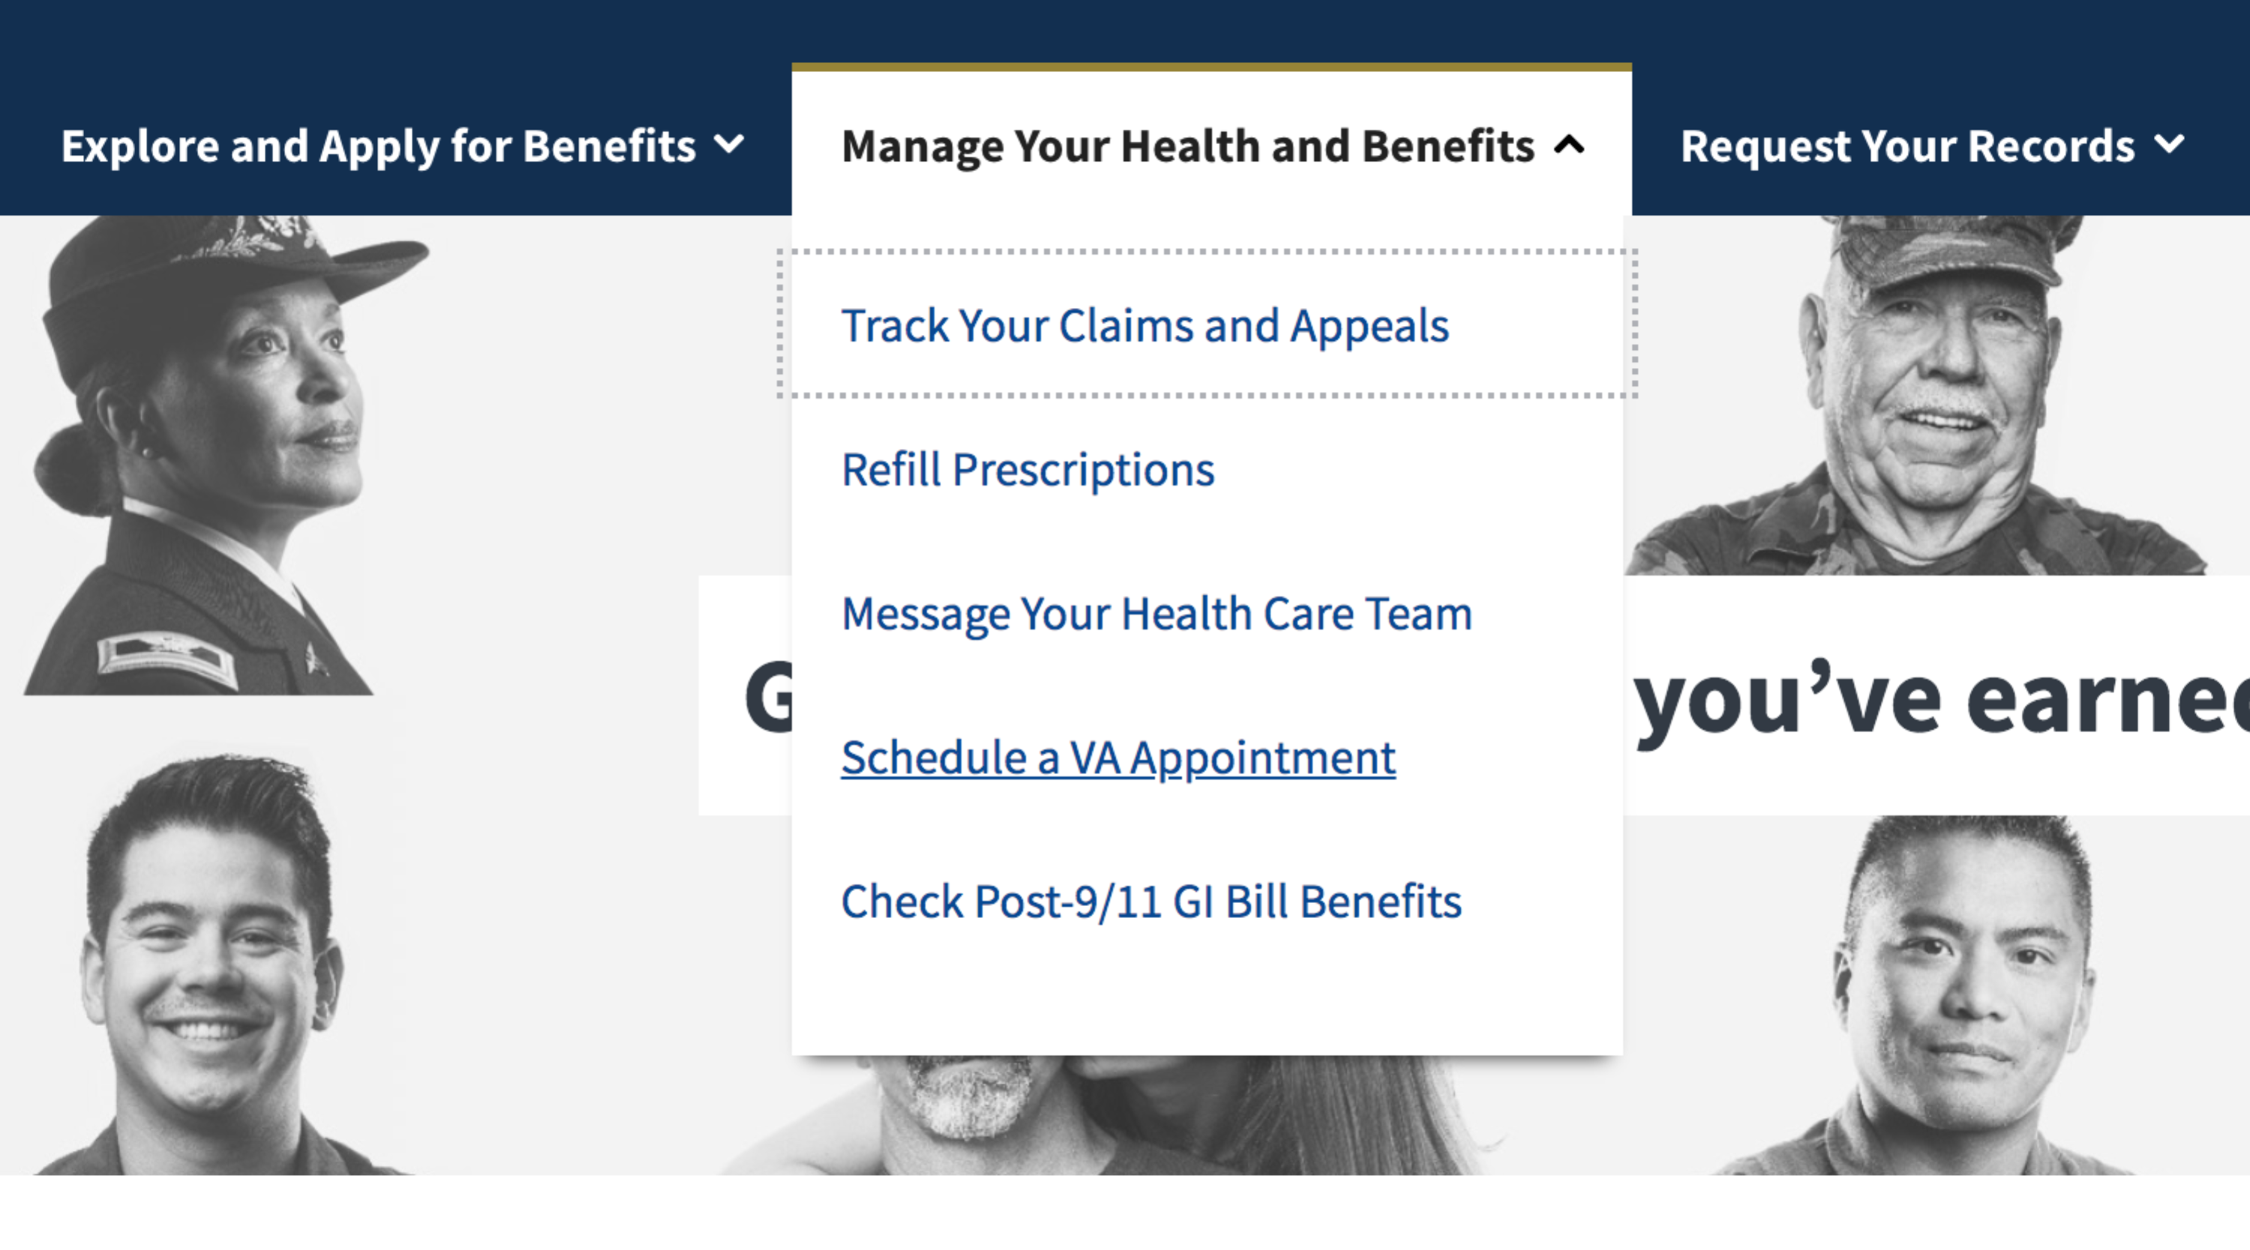

Once users are in their list of Claims and Appeals, users can see the following on each appeals card:

* Type of appeal
* The date of when they received the claim decision
* Quick status of their appeal   
  **Note:** Green circle indicates active status and the gray circle indicates inactive status
* Issues on their appeal
* Button that allows them to view the status in detail

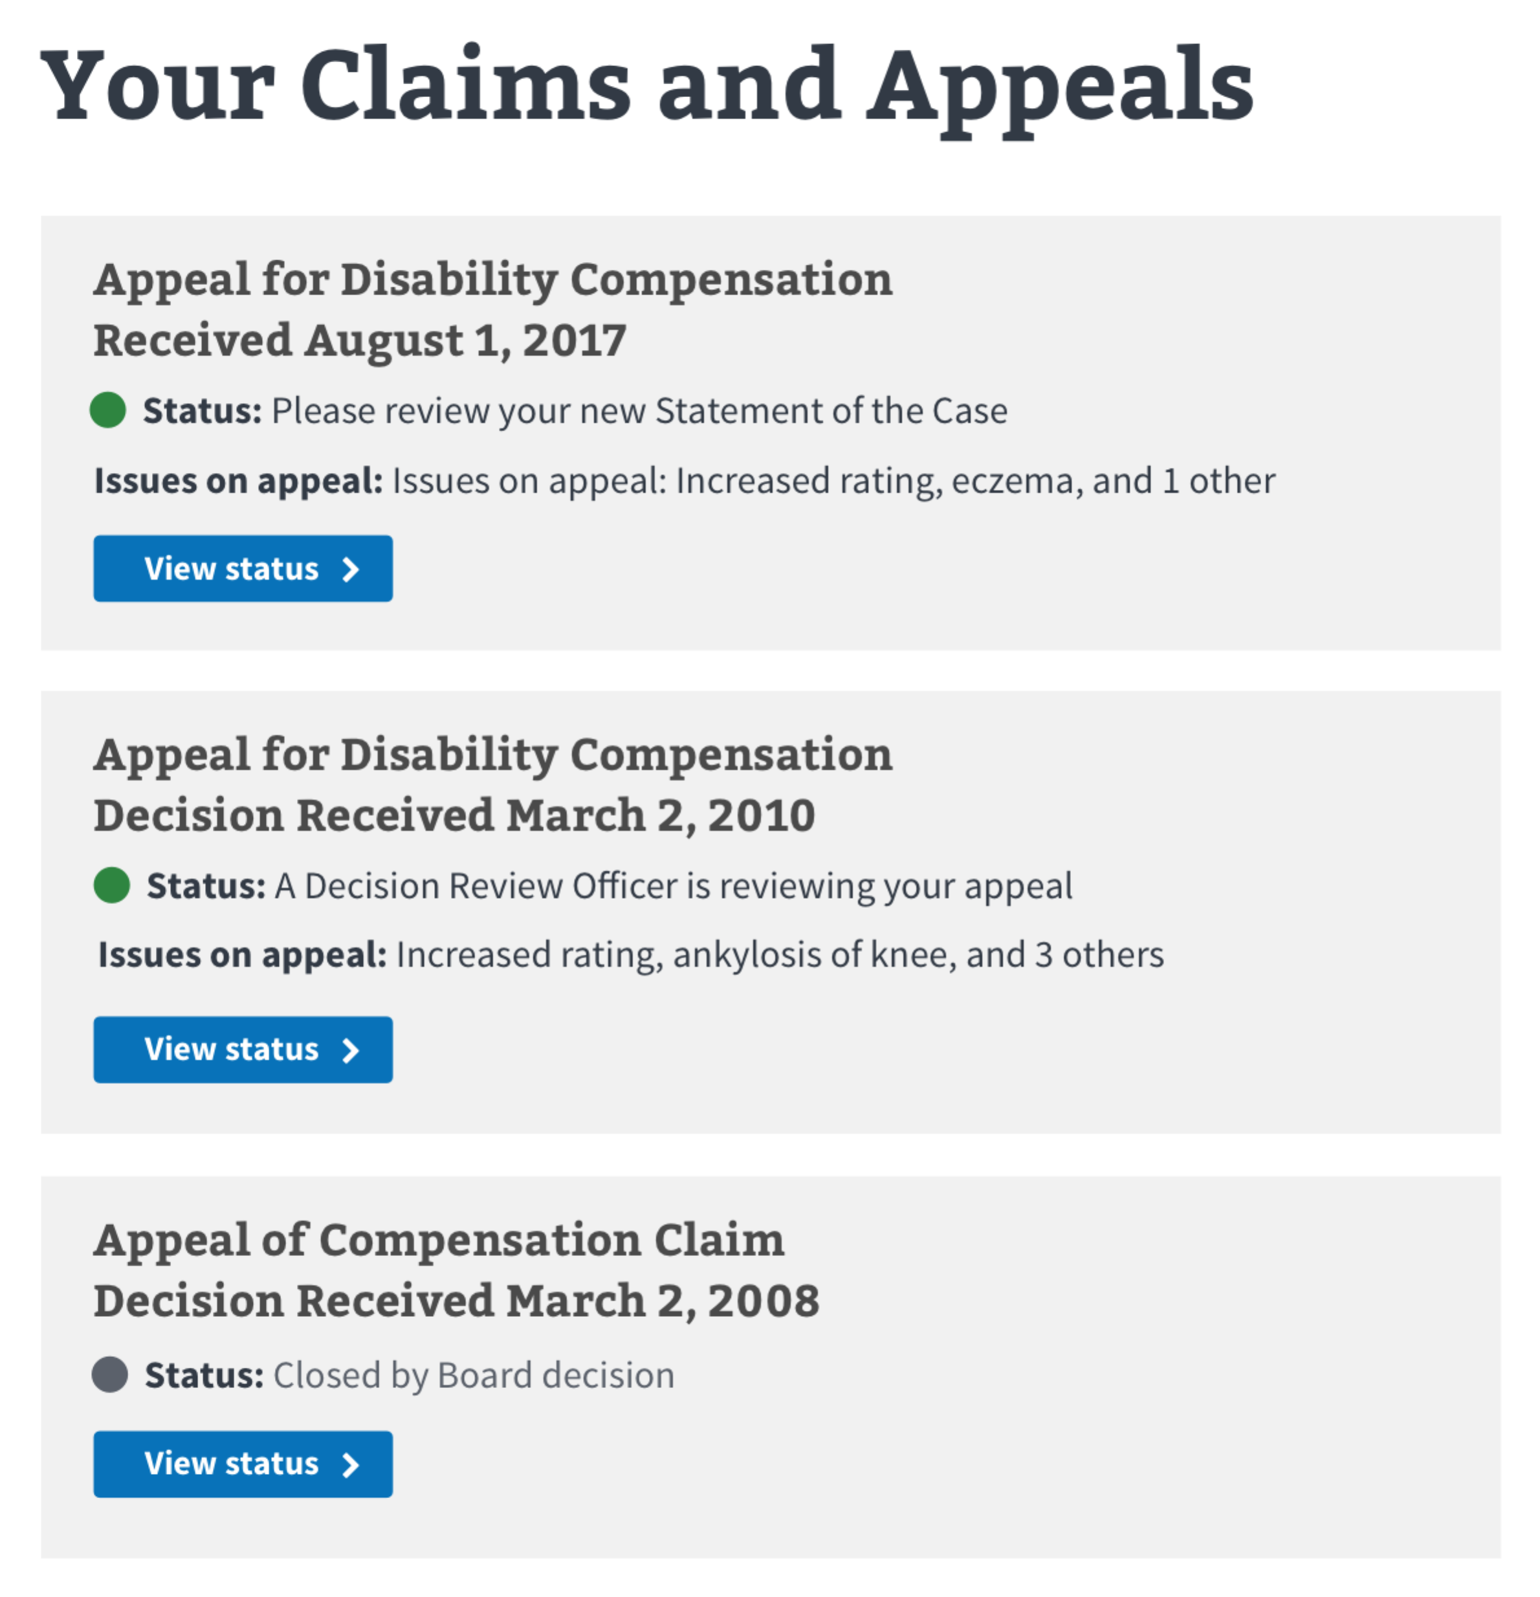

After users click on the view status button, they can see the status of their appeal, include where it is and who is viewing it.

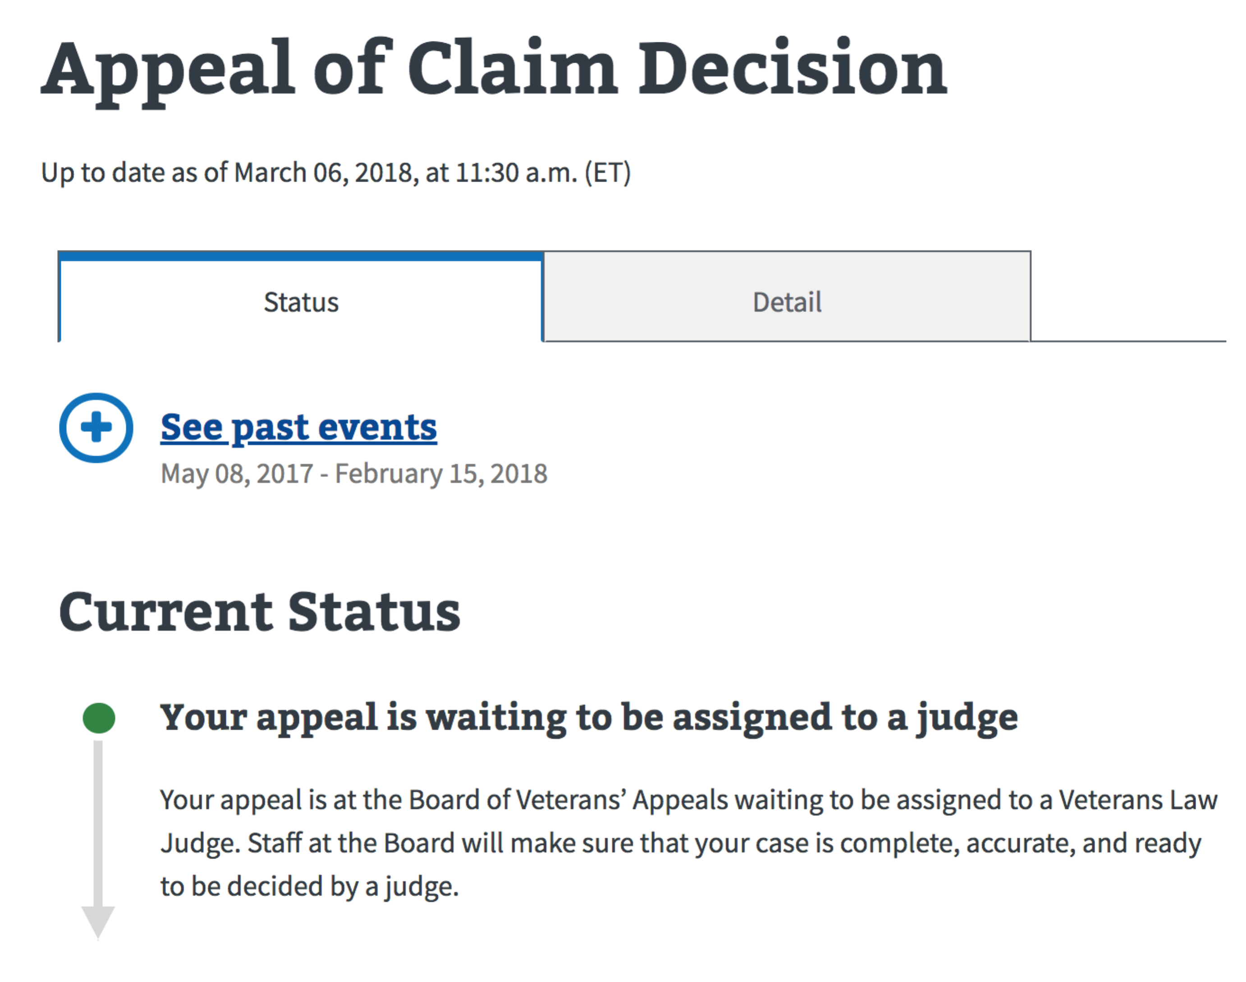

User can click the see past events link to view all the events that happened in the appeal and have led to the current status.

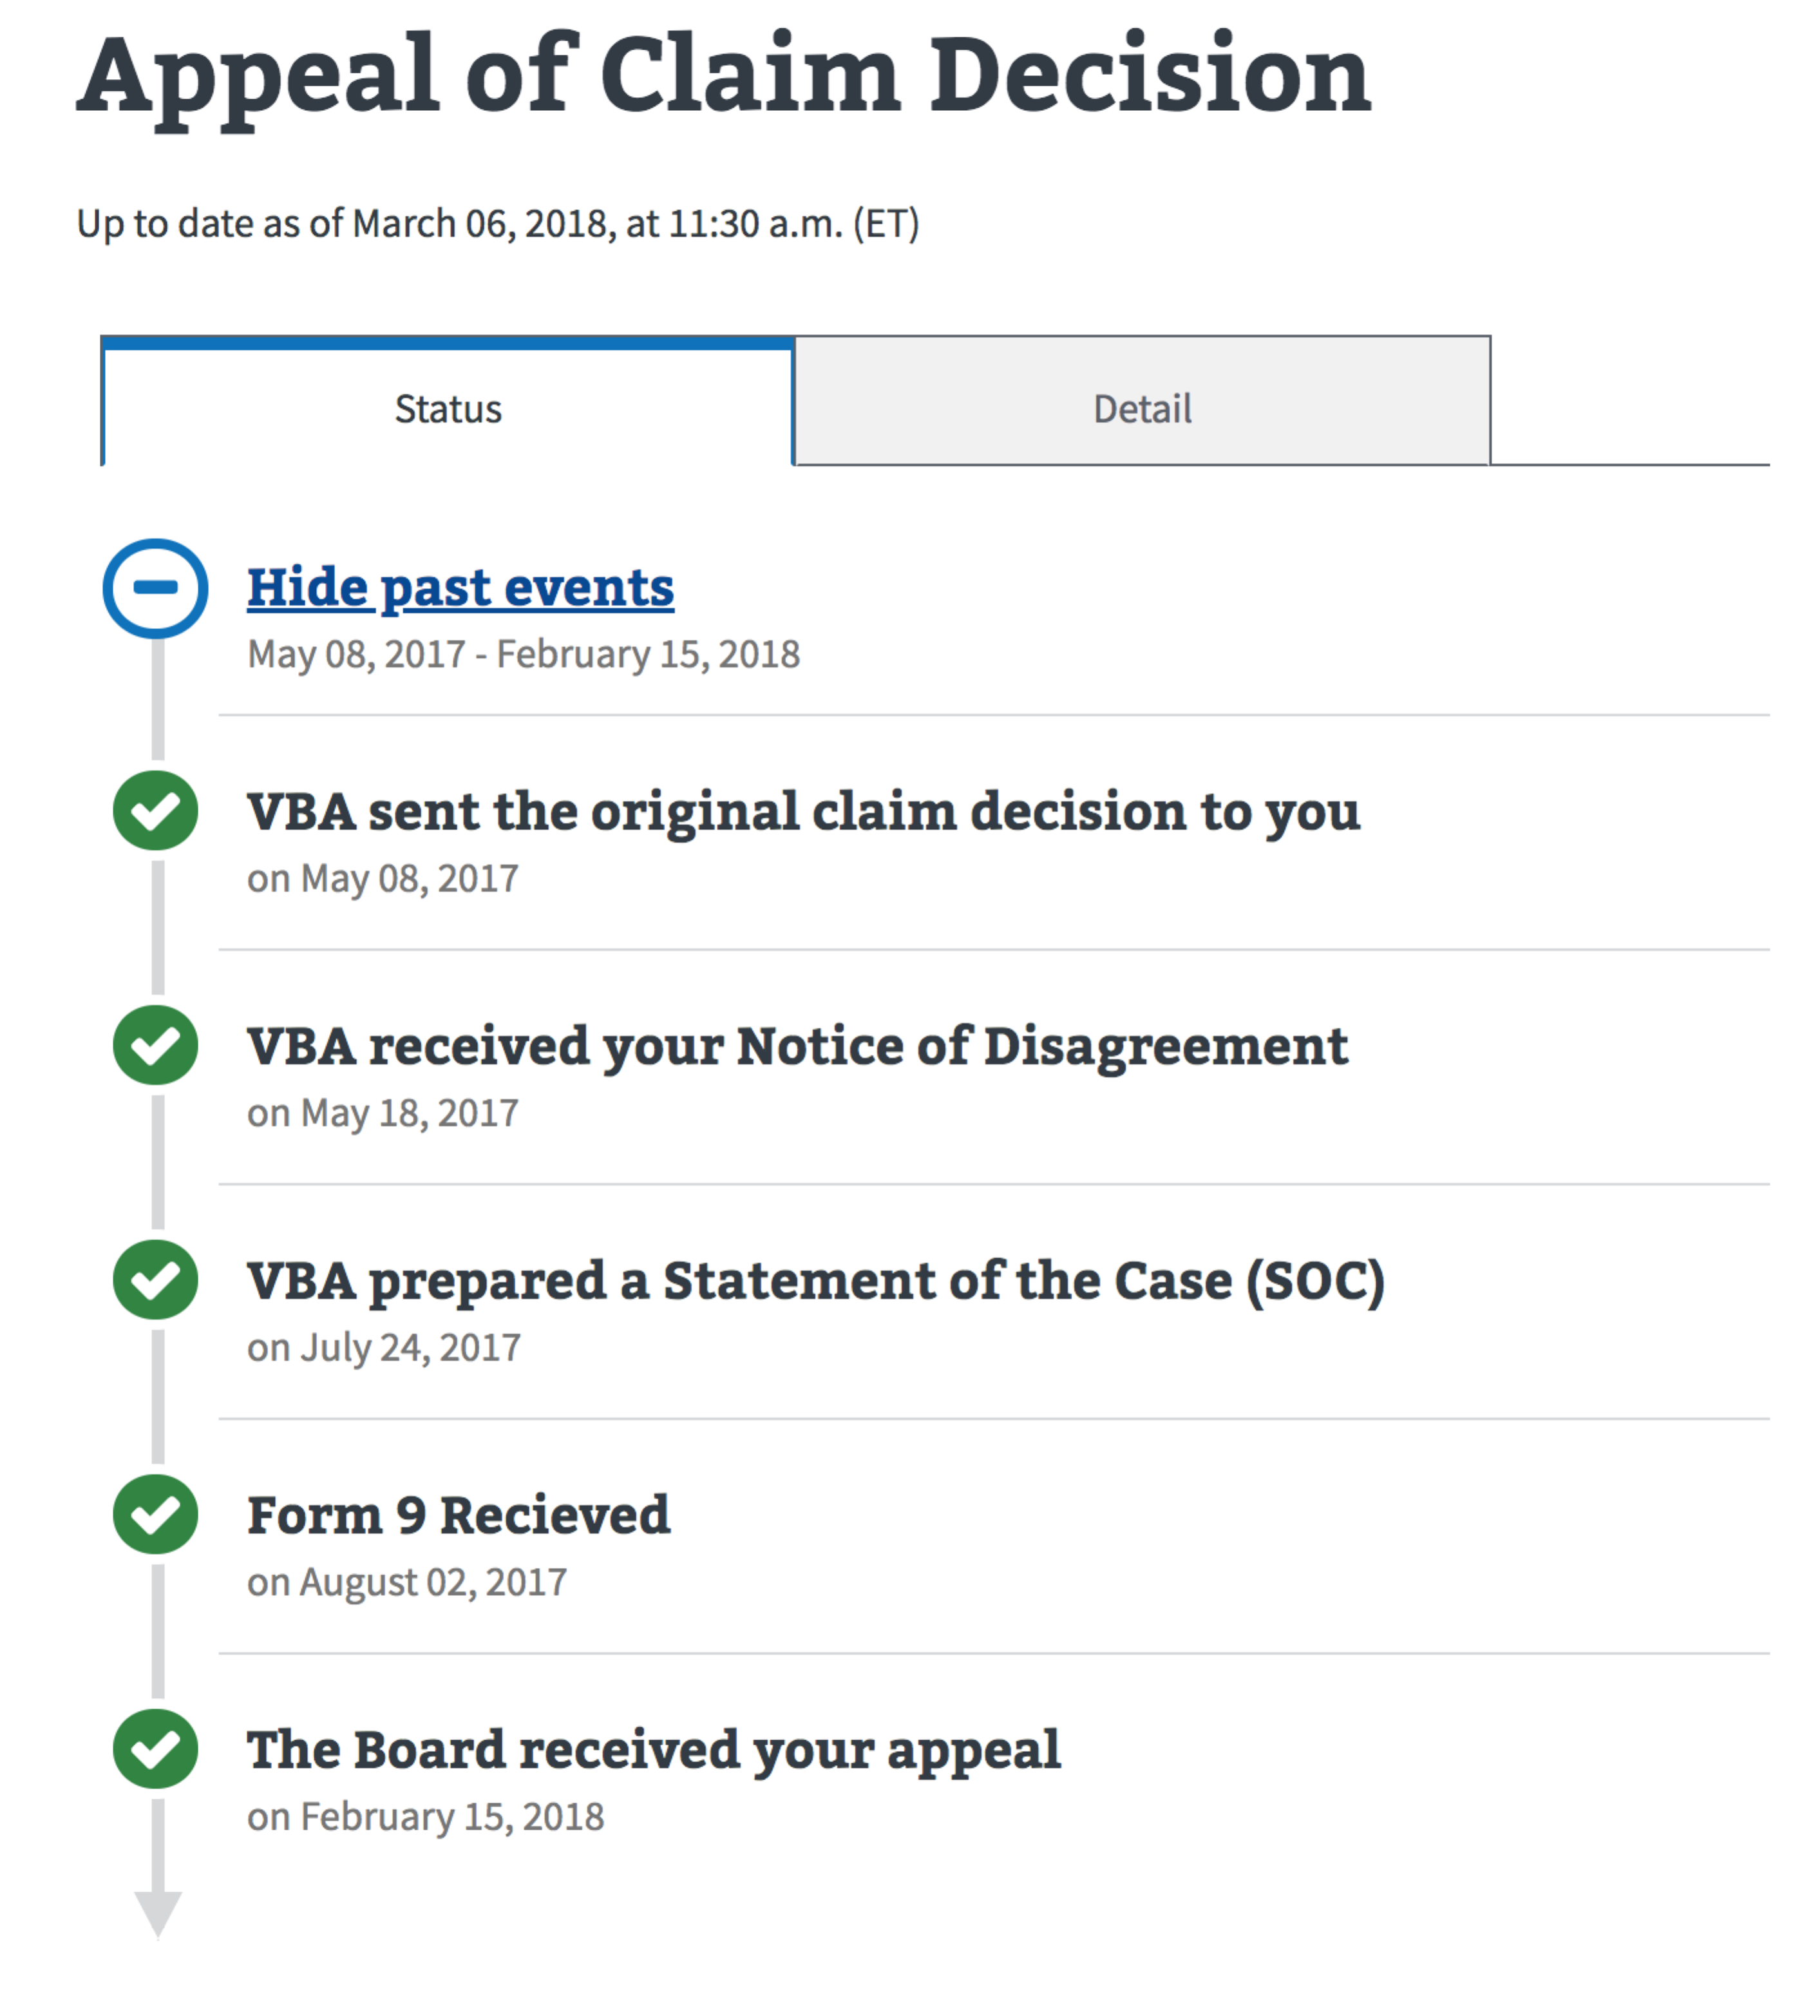

Under the current status, users can see what will happen next with an estimated wait time that shows how long it will take for the next event to take place.

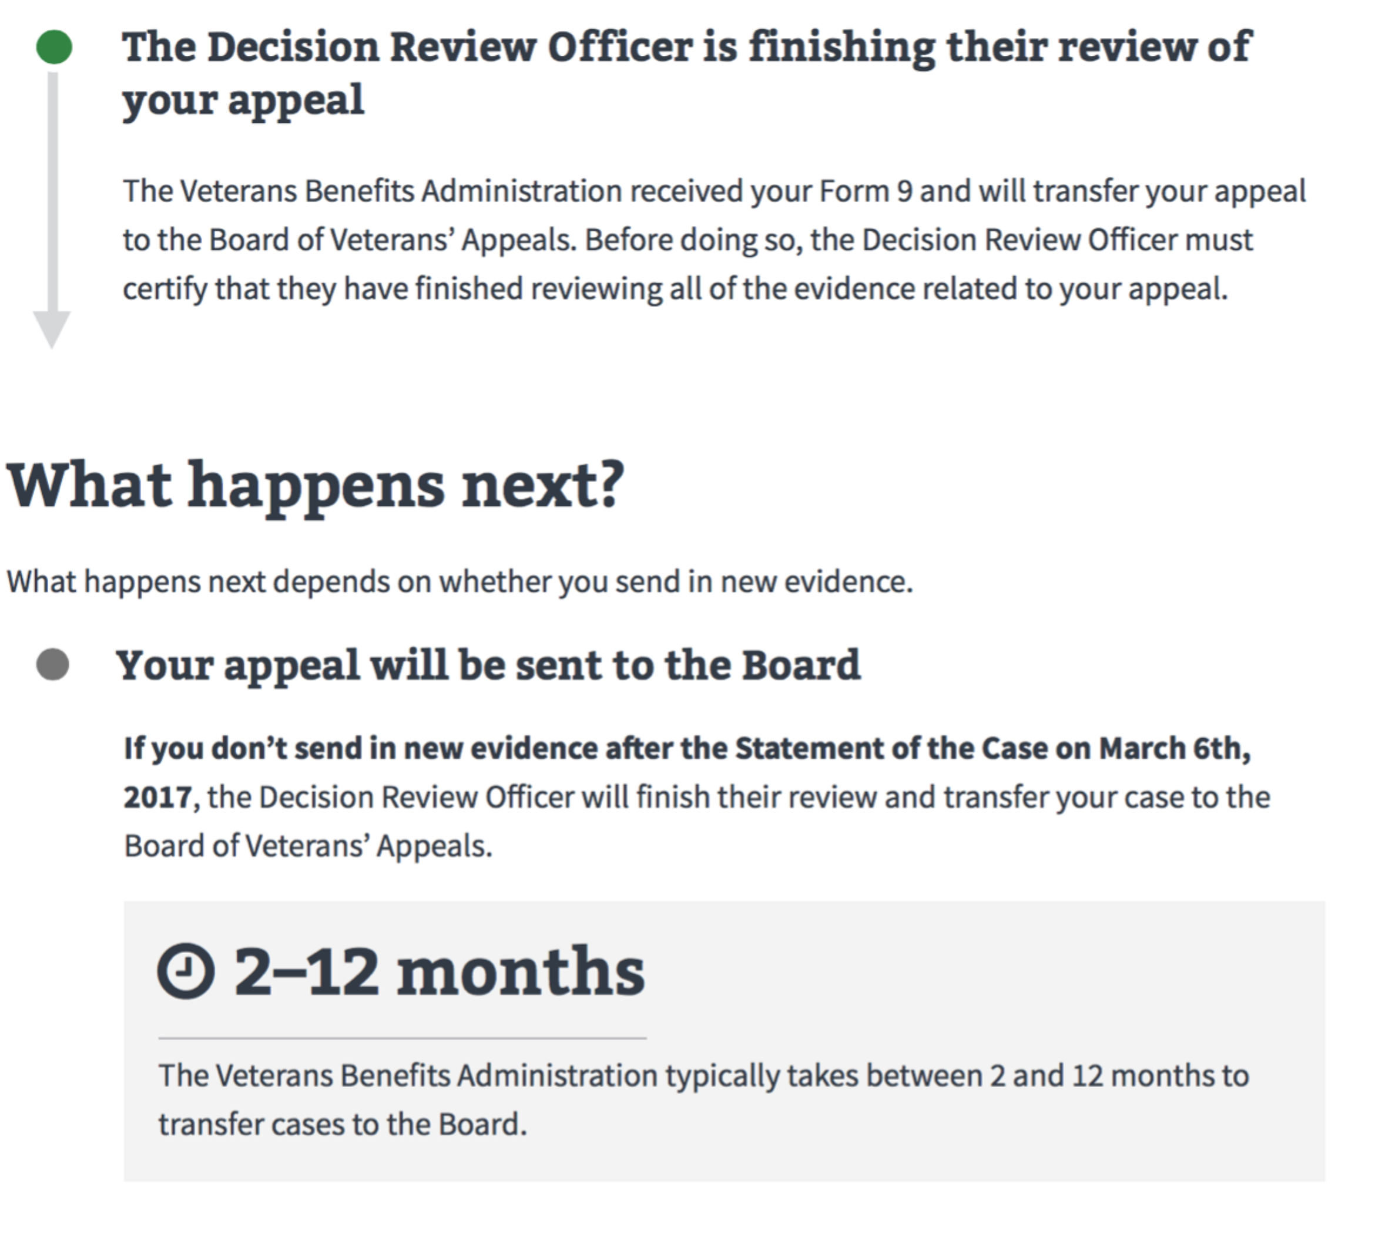

In some cases, users will see multiple wait times and events to allow users to make informed decisions (i.e. submit more evidence) and help users better understand why some events take longer than others.

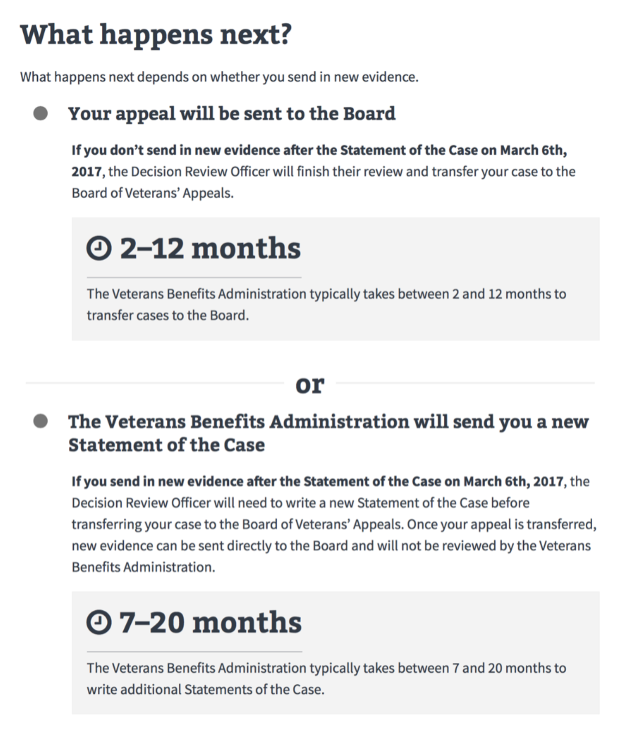

When users decide to continue their appeal at the Board of Veterans` Appeals by submitting the VA Form 9, their appeal gets a spot on a docket line. The Board hears cases in the order they are received. Users can see how many appeals are ahead of them, a graphic that shows that they are moving on the line and the totally number of appeals there are on the docket.

**Note:** This progress bar will only show after VA receives an appellant’s VA Form 9. This progress bar will not show post remand or if the appellant is Advanced on Docket (AOJ) because the appellant will automatically be in front of the docket line.

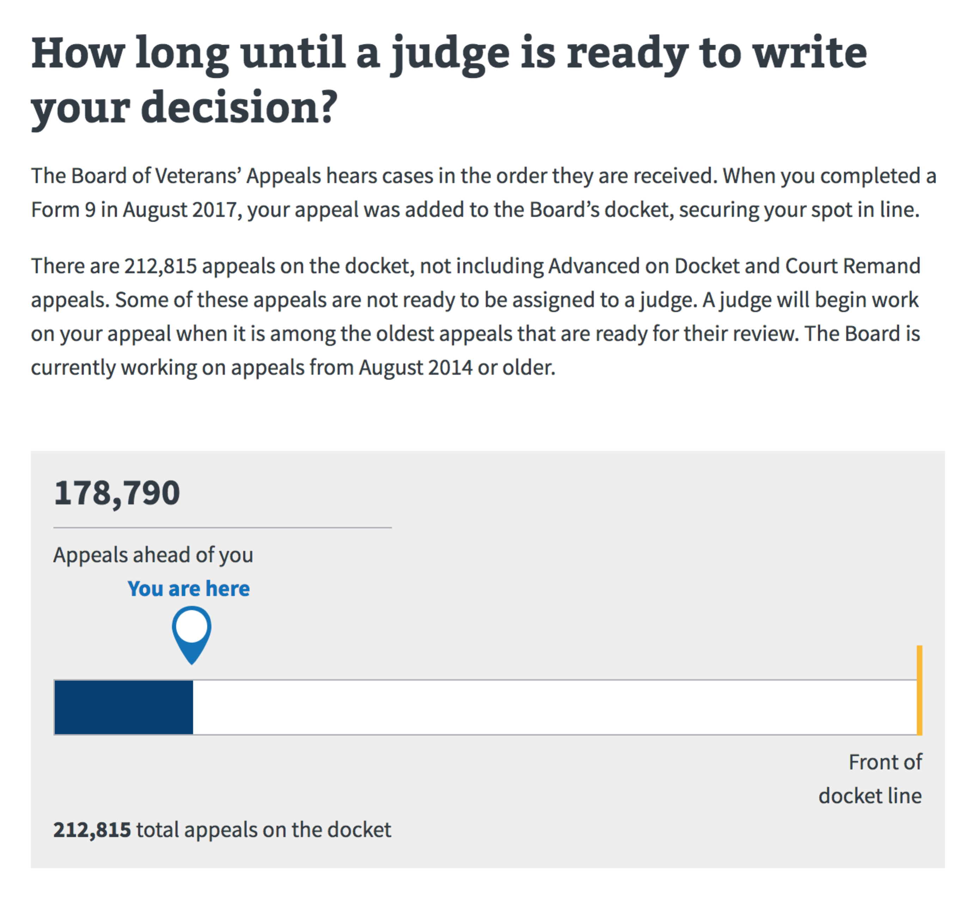

Users can see which issues are on their appeal by clicking on the Issues tab next to Status. Underneath issues currently on appeal, users can view closed issues that have been granted, denied and/ or withdrawn on the appeal by opening the expandable +/- gray accordion.

